**Practical 1**

**Aim:** Create php script for Registration (Include all the necessary HTML5 controls and

attributes) and Display your information in HTML table format on new php page.

**Program:**

1. **PHP input validation code**

<?php

if(count($_POST)>0) {

foreach($_POST as $key=>$value) {

if(empty($_POST[$key])) {

$message = ucwords($key) . " field is required";

break;

}

}

if($_POST['password'] != $_POST['confirm_password']){

$message = 'Passwords should be same<br>';

}

/* Validation */

if(!isset($message)) {

if (!filter_var($_POST["userEmail"], FILTER_VALIDATE_EMAIL)) {

$message = "Invalid UserEmail";

}

}

if(!isset($message)) {

if(!isset($_POST["gender"])) {

$message = " Gender field is required";

}

}

if(!isset($message)) {

if(!isset($_POST["terms"])) {

$message = "Accept Terms and conditions before submit";

}

}

if(!isset($message)) {

require_once("dbcontroller.php");

$db_handle = new DBController();

$query = "INSERT INTO registered_users (user_name, first_name, last_name, password, email, gender) VALUES

('" . $_POST["userName"] . "', '" . $_POST["firstName"] . "', '" . $_POST["lastName"] . "', '" . md5($_POST["password"]) . "', '" . $_POST["userEmail"] . "', '" . $_POST["gender"] . "')";

$result = $db_handle->insertQuery($query);

if(!empty($result)) {

$message = "You have registered successfully!";

unset($_POST);

} else {

$message = "Problem in registration. Try Again!";

}

}

}

?>

1. **HTML Form**

<html>

<head>

<title>PHP User Registration Form</title>

<style>

.message {color: #FF0000;font-weight: bold;text-align: center;width: 100%;padding: 10;}

body{width:610px;}

.demo-table {background:#FFDFDF;width: 100%;border-spacing: initial;margin: 20px 0px;word-break: break-word;table-layout: auto;line-height:1.8em;color:#333;}

.demo-table td {padding: 20px 15px 10px 15px;}

.demoInputBox {padding: 7px;border: #F0F0F0 1px solid;border-radius: 4px;}

.btnRegister {padding: 10px;background-color: #09F;border: 0;color: #FFF;cursor: pointer;}

</style>

</head>

<body>

<form name="frmRegistration" method="post" action="">

<table border="0" width="500" align="center" class="demo-table">

<div class="message"><?php if(isset($message)) echo $message; ?></div>

<tr>

<td>Username</td>

<td><input type="text" class="demoInputBox" name="userName" value="<?php if(isset($_POST['userName'])) echo $_POST['userName']; ?>"></td>

</tr>

<tr>

<td>First Name</td>

<td><input type="text" class="demoInputBox" name="firstName" value="<?php if(isset($_POST['firstName'])) echo $_POST['firstName']; ?>"></td>

</tr>

<tr>

<td>Last Name</td>

<td><input type="text" class="demoInputBox" name="lastName" value="<?php if(isset($_POST['lastName'])) echo $_POST['lastName']; ?>"></td>

</tr>

<tr>

<td>Password</td>

<td><input type="password" class="demoInputBox" name="password" value=""></td>

</tr>

<tr>

<td>Confirm Password</td>

<td><input type="password" class="demoInputBox" name="confirm_password" value=""></td>

</tr>

<tr>

<td>Email</td>

<td><input type="text" class="demoInputBox" name="userEmail" value="<?php if(isset($_POST['userEmail'])) echo $_POST['userEmail']; ?>"></td>

</tr>

<tr>

<td>Gender</td>

<td><input type="radio" name="gender" value="Male" <?php if(isset($_POST['gender']) && $_POST['gender']=="Male") { ?>checked<?php } ?>> Male

<input type="radio" name="gender" value="Female" <?php if(isset($_POST['gender']) && $_POST['gender']=="Female") { ?>checked<?php } ?>> Female

</td>

</tr>

<tr>

<td></td>

<td><input type="checkbox" name="terms"> I accept Terms and Conditions</td>

</tr>

</table>

<div>

<input type="submit" name="submit" value="Register" class="btnRegister">

</div>

</form>

</body></html>

1. **Database code:**

<?php

class DBController {

private $host = "localhost";

private $user = "root";

private $password = "";

private $database = "phppot_examples";

function __construct() {

$conn = $this->connectDB();

if(!empty($conn)) {

$this->selectDB($conn);

}

}

function connectDB() {

$conn = mysql_connect($this->host,$this->user,$this->password);

return $conn;

}

function selectDB($conn) {

mysql_select_db($this->database,$conn);

}

function runQuery($query) {

$result = mysql_query($query);

while($row=mysql_fetch_assoc($result)) {

$resultset[] = $row;

}

if(!empty($resultset))

return $resultset;

}

function numRows($query) {

$result = mysql_query($query);

$rowcount = mysql_num_rows($result);

return $rowcount;

}

function updateQuery($query) {

$result = mysql_query($query);

if (!$result) {

die('Invalid query: ' . mysql_error());

} else {

return $result;

}

}

function insertQuery($query) {

$result = mysql_query($query);

if (!$result) {

die('Invalid query: ' . mysql_error());

} else {

return $result;

}

}

function deleteQuery($query) {

$result = mysql_query($query);

if (!$result) {

die('Invalid query: ' . mysql_error());

} else {

return $result;

}}}

?>

**Output:**

1. Valid form entity:

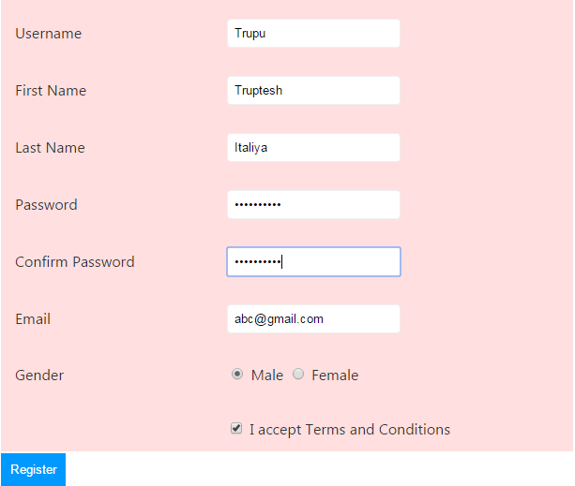

1. Invalid password:

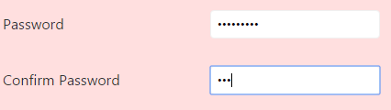



1. Invalid email format:



